# Scenario 9: Add System Users

## Scenario Description

* All functionality relating to an administrator adding new users to the system

## Version Control

|  |  |  |  |
| --- | --- | --- | --- |
| Version # | Date | Author | Description |
| 1.0 | 20/09/2019 | Brodie Osborn | Initial Version |

## Test Scripts

The following scripts will cover this scenario:

* 9.1 Add new user

## Use Case

* Add system users

## Test Components/Requirements

This test scenario covers the following high-level test requirements (see scripts below for specific requirements covered by each test script):

* Ensure that administrators can add new users

## User Groups

* Administrators

## Script 9.1: Add System User

### Script Description

* An administrator can successfully add a new user to the system

### Testing Requirements

This test script covers the following specific testing requirements:

* Ensure that an administrator can add a new user

### Setup

* An administrator must be signed in and on the Users page

### Teardown

### Script Steps

| **Step #** | **Test Action** | **Expected Results** | **Pass/ Fail** |
| --- | --- | --- | --- |
| 1 | Click “Add User” button | Display the New User page | PASS |
| 2 | Enter the following User information: Username: JohnDoe, Email: [jDoe@gmail.com](mailto:jDoe@gmail.com), Password: password  Confirm new User creation | Create new User account  Return to Users page. New User should be show in the list of users | PASS |

### Test Execution

|  |  |  |  |  |
| --- | --- | --- | --- | --- |
| Date/Time | Tester | Test ID | Test Phase | Status |
| 23/09/2019 | Brodie Osborn | #1 | IOCM | Complete |

**Screenshot 1**

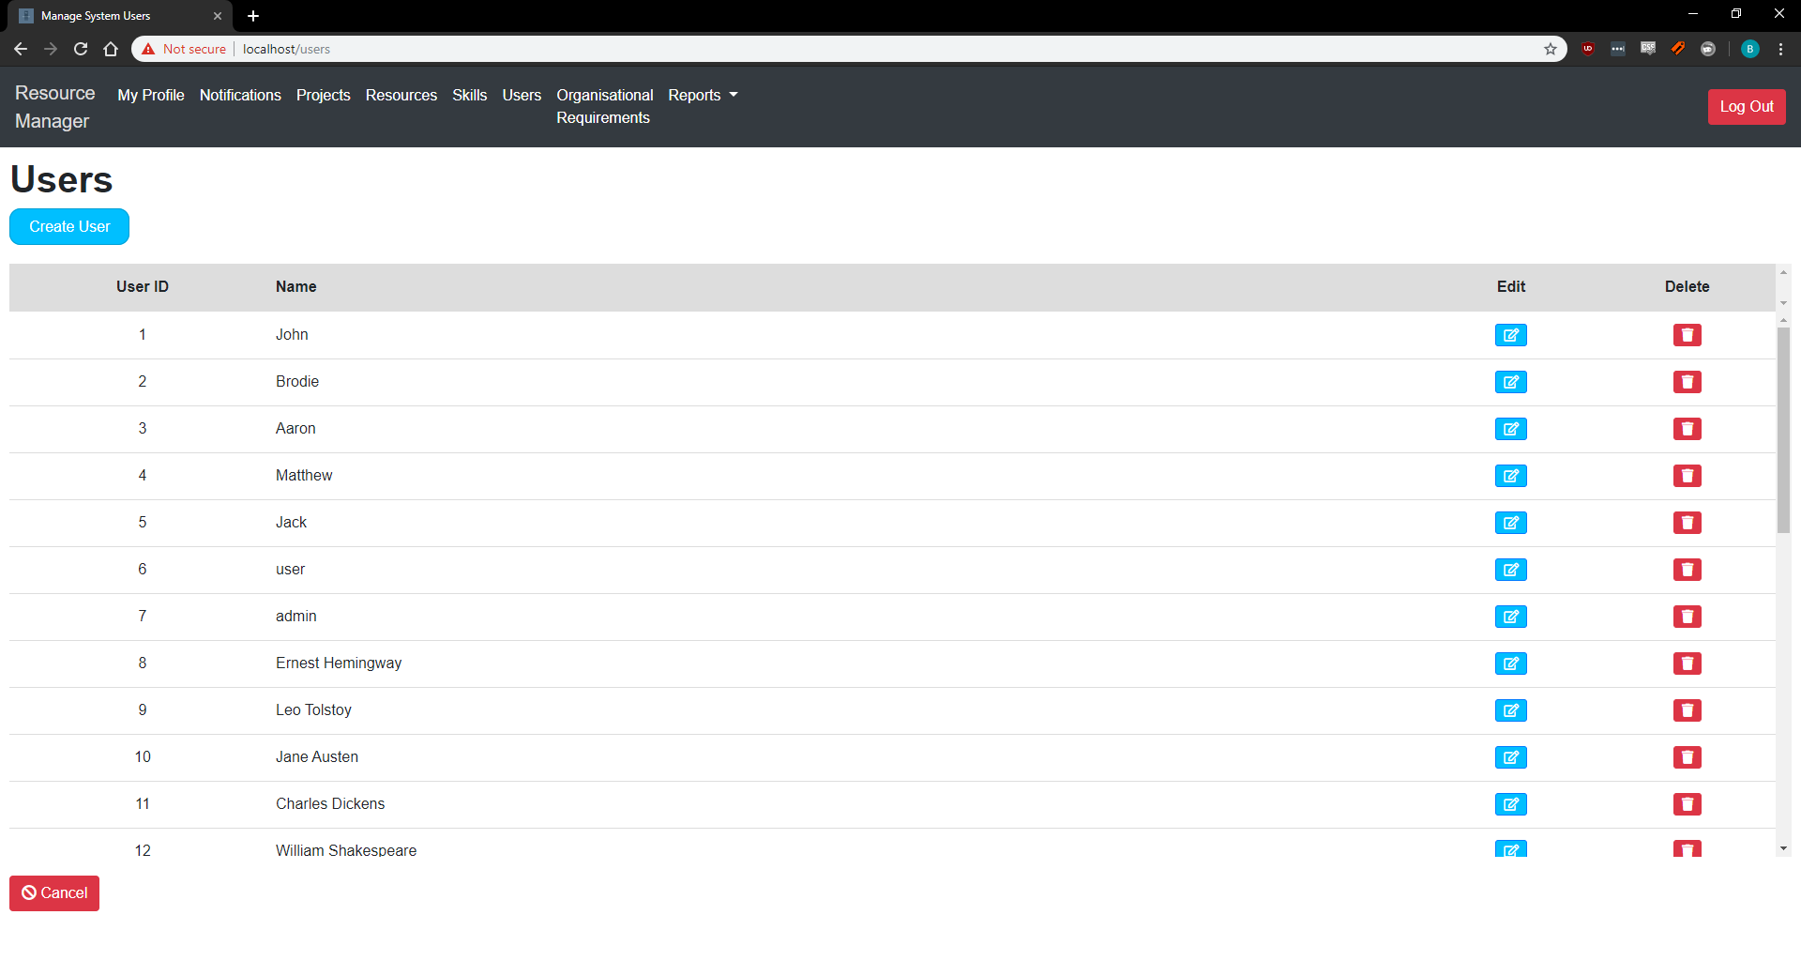

**Screenshot 2**

